Multiple Condition Coverage (MCC)

What is Multiple Condition Coverage (MCC)
# Source: AI Source: Provided by: [Data Path: Persons Table -> ID Column: 1, Name_En Column: Motasem Essam] -> From: [Chatgpt (GPT‑5 Mini)] on [8/24/2025]
Multiple Condition Coverage (MCC) is a white-box testing technique where all possible combinations of individual conditions within a decision are tested at least once.
It is the most thorough extension of condition testing because instead of just making each condition True and False at some point, MCC requires testing every possible combination of conditions.

🔍 Example 1:
# Source: AI Source: Provided by: [Data Path: Persons Table -> ID Column: 1, Name_En Column: Motasem Essam] -> From: [Chatgpt (GPT‑5 Mini)] on [8/24/2025]
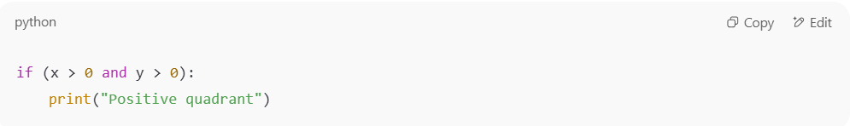
if (x > 0 and y > 0):
print("Positive quadrant")

- Conditions:
  - x > 0
  - y > 0
👉 Possible combinations:
- x > 0 = True, y > 0 = True
- x > 0 = True, y > 0 = False
- x > 0 = False, y > 0 = True
- x > 0 = False, y > 0 = False
✅ To achieve MCC, we must test all 4 combinations.

🔍 Example 2 (with OR):
# Source: AI Source: Provided by: [Data Path: Persons Table -> ID Column: 1, Name_En Column: Motasem Essam] -> From: [Chatgpt (GPT‑5 Mini)] on [8/24/2025]
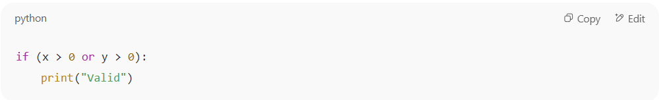
if (x > 0 or y > 0):
print("Valid")

- Conditions:
  - x > 0
  - y > 0
👉 Possible combinations:
- x > 0 = True, y > 0 = True
- x > 0 = True, y > 0 = False
- x > 0 = False, y > 0 = True
- x > 0 = False, y > 0 = False
✅ MCC requires all 4 cases.

📊 Formula for Multiple Condition Coverage:
# Source: AI Source: Provided by: [Data Path: Persons Table -> ID Column: 1, Name_En Column: Motasem Essam] -> From: [Chatgpt (GPT‑5 Mini)] on [8/24/2025]
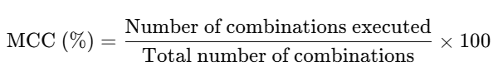
MCC (%)=Number of combinations executedTotal number of combinations×100\text{MCC (\%)} = \frac{\text{Number of combinations executed}}{\text{Total number of combinations}} \times 100

✅ Why is it stronger?
# Source: AI Source: Provided by: [Data Path: Persons Table -> ID Column: 1, Name_En Column: Motasem Essam] -> From: [Chatgpt (GPT‑5 Mini)] on [8/24/2025]
- Statement Coverage: Every statement runs at least once.
- Decision Coverage: Every decision outcome (True/False) is tested.
- Condition Coverage: Every atomic condition is tested as True and False.
- Multiple Condition Coverage: Every possible combination of condition outcomes is tested.
👉 MCC gives maximum confidence in testing logical decisions.

⚖️ Advantages:
# Source: AI Source: Provided by: [Data Path: Persons Table -> ID Column: 1, Name_En Column: Motasem Essam] -> From: [Chatgpt (GPT‑5 Mini)] on [8/24/2025]
- Catches subtle logical errors in complex decisions.
- Provides highest level of confidence in decision testing.

⚠️ Limitations:
# Source: AI Source: Provided by: [Data Path: Persons Table -> ID Column: 1, Name_En Column: Motasem Essam] -> From: [Chatgpt (GPT‑5 Mini)] on [8/24/2025]
- Combinatorial explosion: If a decision has n conditions, there are 2^n combinations.
  - For example: 5 conditions → 32 test cases needed.
- Not always practical for large systems.

✅ In short:
Multiple Condition Coverage = Test all possible True/False combinations of conditions inside a decision.
It’s the strongest but most expensive form of decision-based white-box testing.

